**Задача 1.**

--q1

**create** **view** tz_table **as** (**select**

f.actual_departure **at** **time** **zone** ad.timezone **as** tz,

**extract** (**hour** **from** f.actual_departure **at** **time** **zone** ad.timezone) **as** **hour**,

**case** **when** (**extract** (**hour** **from** f.actual_departure **at** **time** **zone** ad.timezone) **between** 21 **and** 23) **or**

(**extract** (**hour** **from** f.actual_departure **at** **time** **zone** ad.timezone) **between** 0 **and** 1) **then** 'evening'

**when** **extract** (**hour** **from** f.actual_departure **at** **time** **zone** ad.timezone) **between** 6 **and** 9 **then** 'morning'

**else** 'other'

**end** **as** **period**,

f.departure_airport || '-' || f.arrival_airport **as** destination

**from** bookings.flights f

**left** **join** bookings.airports_data ad

**on** f.departure_airport = ad.airport_code

**where** actual_departure **is** **not** **null**

**and** **extract** (**year** **from** f.actual_departure **at** **time** **zone** ad.timezone) = 2017

**and** **extract** (**month** **from** f.actual_departure **at** **time** **zone** ad.timezone) = 3)

**select**

(**select** **count**(*) **filter**(**where** **period** = 'evening') **from** tz_table) **as** evening_flights,

(**select** **count**(*) **filter**(**where** **period** = 'morning') **from** tz_table) **as** morning_flights,

(**select** destination

**from** tz_table

**where** **period** = 'morning'

**group** **by** destination

**order** **by** **count**(destination) **desc**

**limit** 1) **as** morning_destination,

(**select** destination

**from** tz_table

**where** **period** = 'evening'

**group** **by** destination

**order** **by** **count**(destination) **desc**

**limit** 1) **as** evening_destination

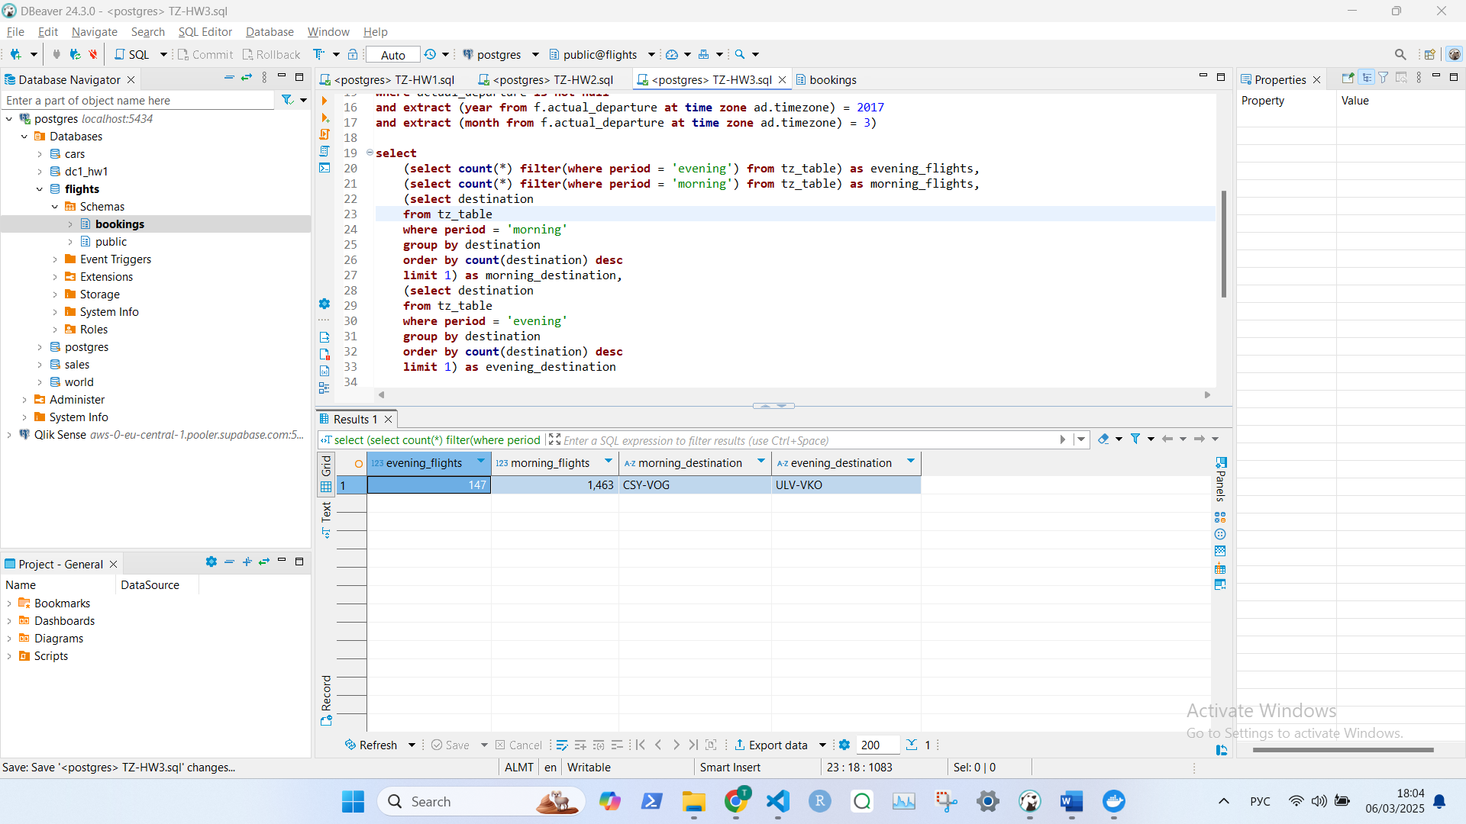

**Задача 2.**

**with** main_table **as** (**select**

**date_trunc**('day', f.actual_departure **at** **time** **zone** 'Europe/Moscow')::**date** **as** *departure_day*,

fare_conditions,

**sum**(amount)

**from**

bookings.flights *f*

**left** **join** bookings.ticket_flights *tf*

**on** *f*.flight_id = *tf*.flight_id

**where** actual_departure **is** **not** **null**

**and** **extract** (**year** **from** *f*.actual_departure **at** **time** **zone** 'Europe/Moscow') = 2017

**and** **extract** (**month** **from** f.actual_departure **at** **time** **zone** 'Europe/Moscow') = 3

**and** amount **is** **not** **null**

**group** **by** departure_day, fare_conditions

**order** **by** departure_day **asc**)

**select** departure_day, fare_conditions, **sum**(**sum**) **as** **sum**

**from** main_table

**group** **by** departure_day, fare_conditions

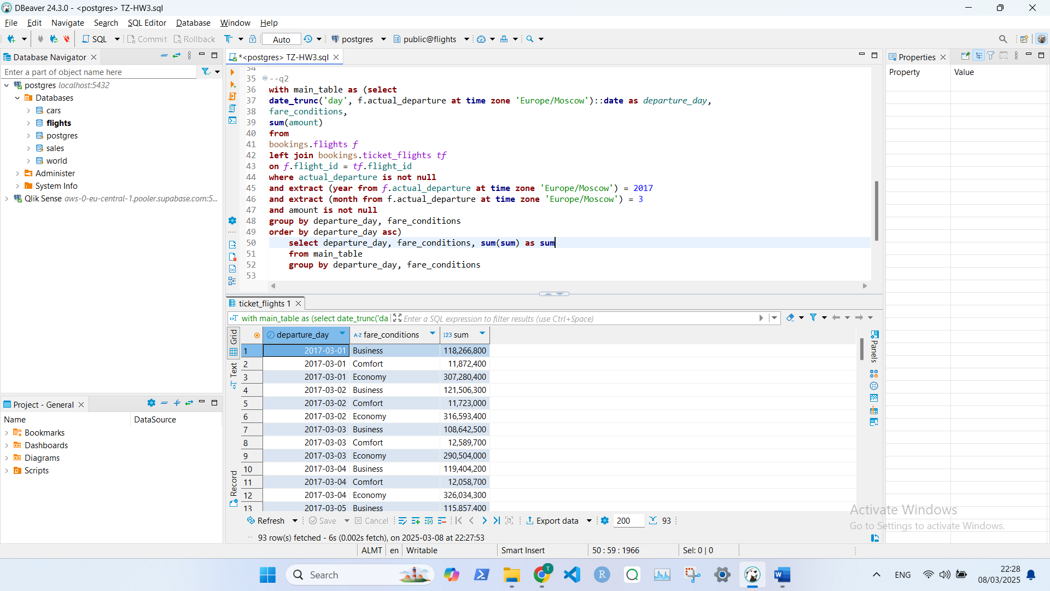

**Задача 3.**

**with** *wheels_orders* **as** (**select** **distinct** *s*.salesorderid **from** productsubcategory *p*

**left** **join** product *p2*

**on** *p*.productsubcategoryid = *p2*.productsubcategoryid

**left** **join** salesorderdetail *s*

**on** *p2*.productid = *s*.productid

**where** *p*."name" = 'Wheels'

**and** salesorderid **is** **not** **null**)

**select** *p*.productsubcategoryid, *p*."name", **count**(*s*.salesorderid)

**from** productsubcategory *p*

**left** **join** product *p2*

**on** *p*.productsubcategoryid = *p2*.productsubcategoryid

**left** **join** salesorderdetail *s*

**on** *p2*.productid = *s*.productid

**where** *s*.salesorderid **in** (**select** salesorderid **from** *wheels_orders*)

**and** *p*."name" <> 'Wheels'

**group** **by** 1,2

**order** **by** 3 **desc**

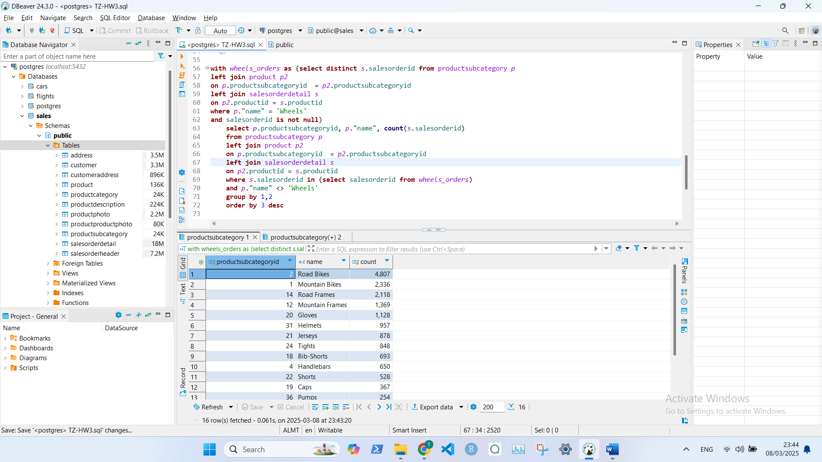

**Задача 4.**

**with** *first_cte* **as** (**select** **left**(name, 1) **as** *first_letter* **from** country *c*)

**select** *first_letter*, **count**(*first_letter*) **as** *cnt*

**from** *first_cte*

**group** **by** *first_letter*

**order** **by** *cnt* **desc**

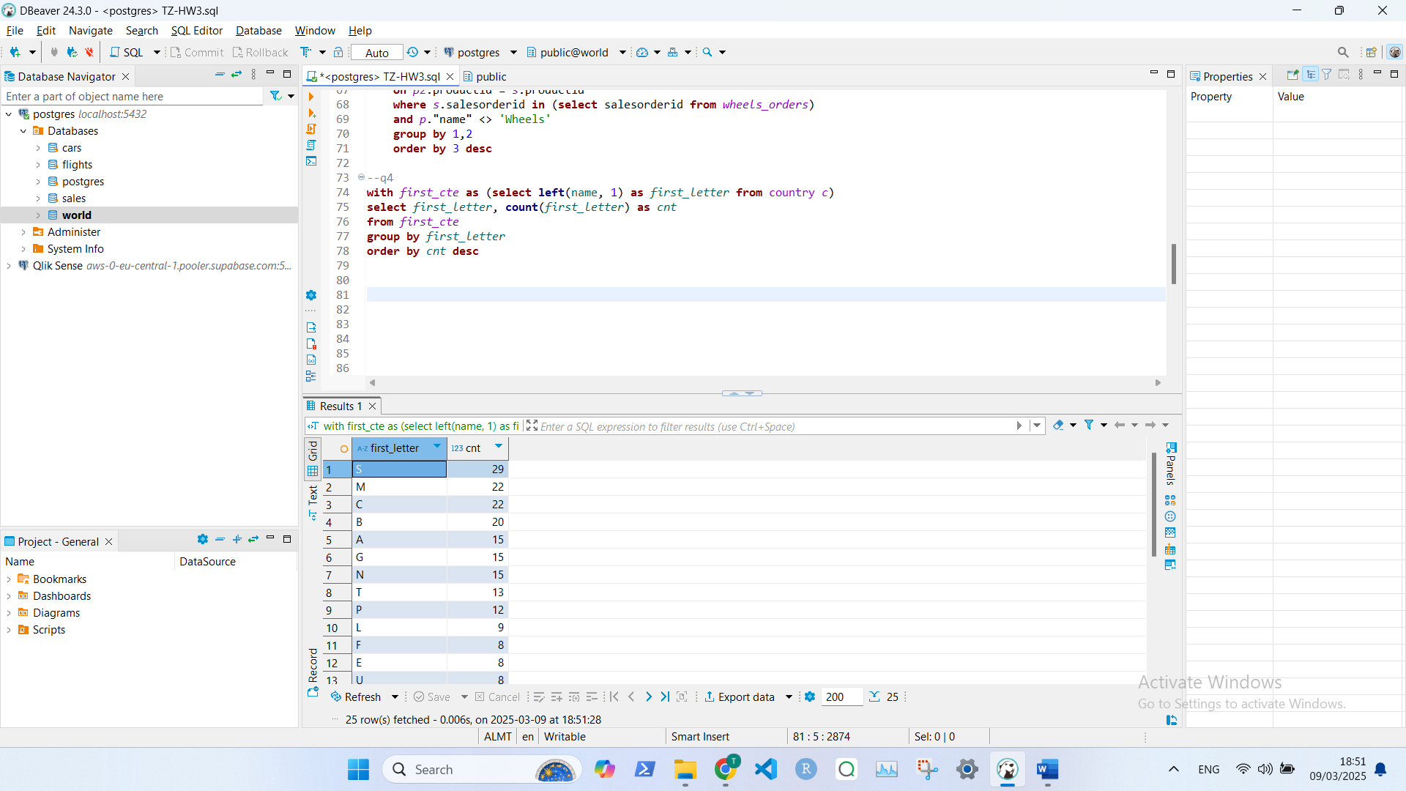

**Задача 5.**

**with** *english_german* **as** (**select** *c*.code, *c*.name, *c2*.language, *c2*.isofficial

**from** country *c*

**left** **join** countrylanguage *c2*

**on** *c*.code = *c2*.countrycode

**where** isofficial = **true**

**and** language **in** ('English', 'German')

**order** **by** name, isofficial **desc**)

**select** **count**(*) **from** *english_german*

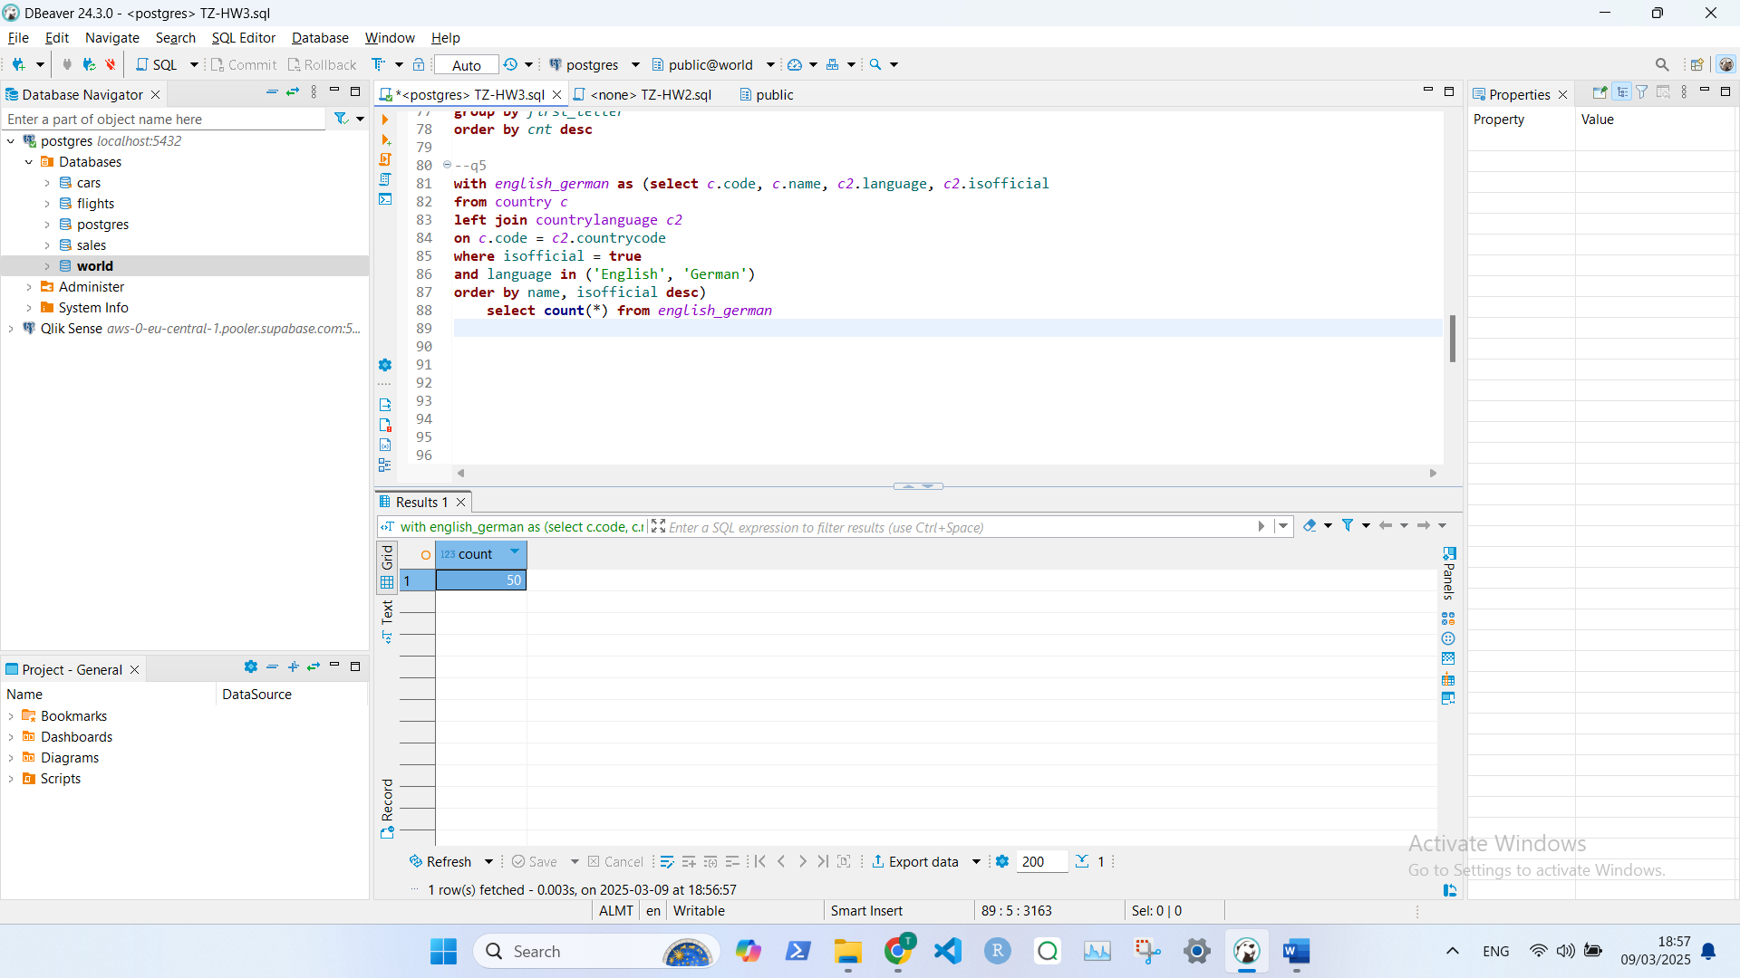

**Задача 6.**

**with** *region_life* **as** (**select** region, **avg**(lifeexpectancy) **as** *avg_life*

**from** country *c*

**group** **by** region

**having** **avg**(lifeexpectancy) > 0)

**select** name, *c*.region, lifeexpectancy, *avg_life* **from** country *c*

**left** **join** *region_life*

**on** *c*.region = *region_life*.region

**where** lifeexpectancy > *avg_life*

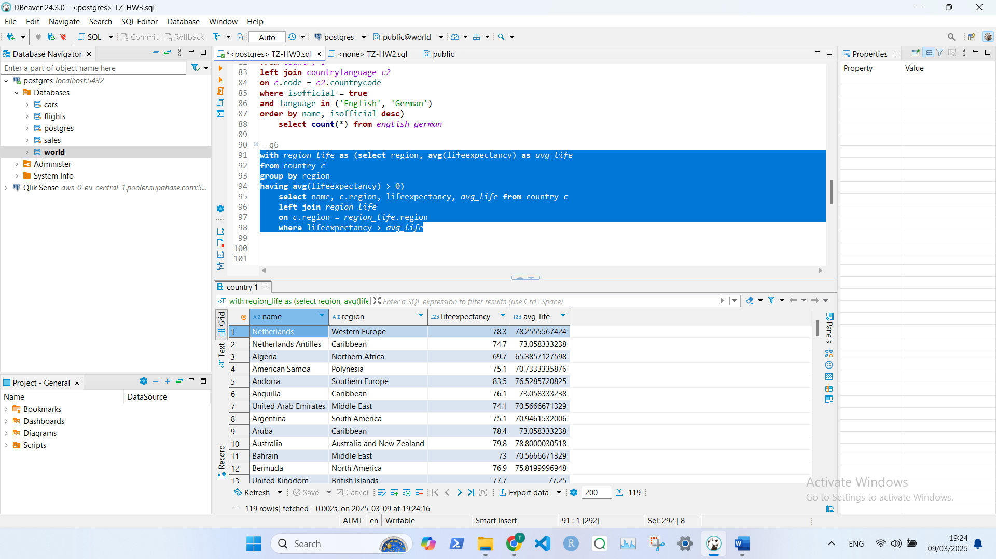

**Задача 7.**

**with** *africa* **as** (**select** language **from** country *c*

**left** **join** countrylanguage *c2*

**on** *c*.code = *c2*.countrycode

**where** *c*.continent **in** ('Africa')),

*asia* **as** (**select** language **from** country *c*

**left** **join** countrylanguage *c2*

**on** *c*.code = *c2*.countrycode

**where** *c*.continent **in** ('Asia'))

**select** **distinct** *africa*.language **from** *africa* **inner** **join** *asia*

**ON** *africa*.language = *asia*.language

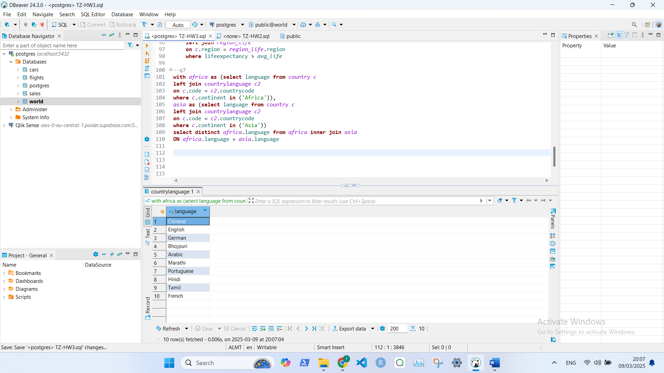

**Задача 8.**

**with** *Sales_2012* **as** (**select** **date_trunc**('month', orderdate)::**date** **as** *order_month*,

*p3*.name **as** *category_name*, **sum**(linetotal) **as** *Sales_2012*

**from** salesorderdetail *s*

**left** **join** salesorderheader *s2* **ON** *s*.salesorderid = *s2*.salesorderid

**left** **join** product *p* **on** *p*.productid = *s*.productid

**left** **join** productsubcategory *p2* **on** *p2*.productsubcategoryid = *p*.productsubcategoryid

**left** **join** productcategory *p3* **on** *p3*.productcategoryid = *p2*.productcategoryid

**where** **date_trunc**('month', orderdate)::**date** **between** '2012-01-01' **and** '2012-12-01'

**group** **by** *order_month*, *category_name*

**order** **by** *order_month* **asc**, *category_name* **asc**),

*Sales_2013* **as** (**select** (**date_trunc**('month', orderdate) - INTERVAL '1 year')::**date** **as** *order_month*,

*p3*.name **as** *category_name*, **sum**(linetotal) **as** *Sales_2013*

**from** salesorderdetail *s*

**left** **join** salesorderheader *s2* **ON** *s*.salesorderid = *s2*.salesorderid

**left** **join** product *p* **on** *p*.productid = *s*.productid

**left** **join** productsubcategory *p2* **on** *p2*.productsubcategoryid = *p*.productsubcategoryid

**left** **join** productcategory *p3* **on** *p3*.productcategoryid = *p2*.productcategoryid

**where** **date_trunc**('month', orderdate)::**date** **between** '2013-01-01' **and** '2013-12-01'

**group** **by** *order_month*, *category_name*

**order** **by** *order_month* **asc**, *category_name* **asc**)

**select** *Sales_2012*.*category_name*,

*Sales_2012*.*order_month* **as** *order__month_2012*,

*Sales_2012*,

(*Sales_2013*.*order_month* + INTERVAL '1 year')::**date** **as** *order__month_2013*,

*Sales_2013*,

**round**((*Sales_2013*-*Sales_2012*)/*Sales_2012*,2) **as** *percentage_change*

**from** *Sales_2012* **inner** **join** *Sales_2013* **on**

*Sales_2012*.*order_month* = *Sales_2013*.*order_month*

**and** *Sales_2012*.*category_name* = *Sales_2013*.*category_name*

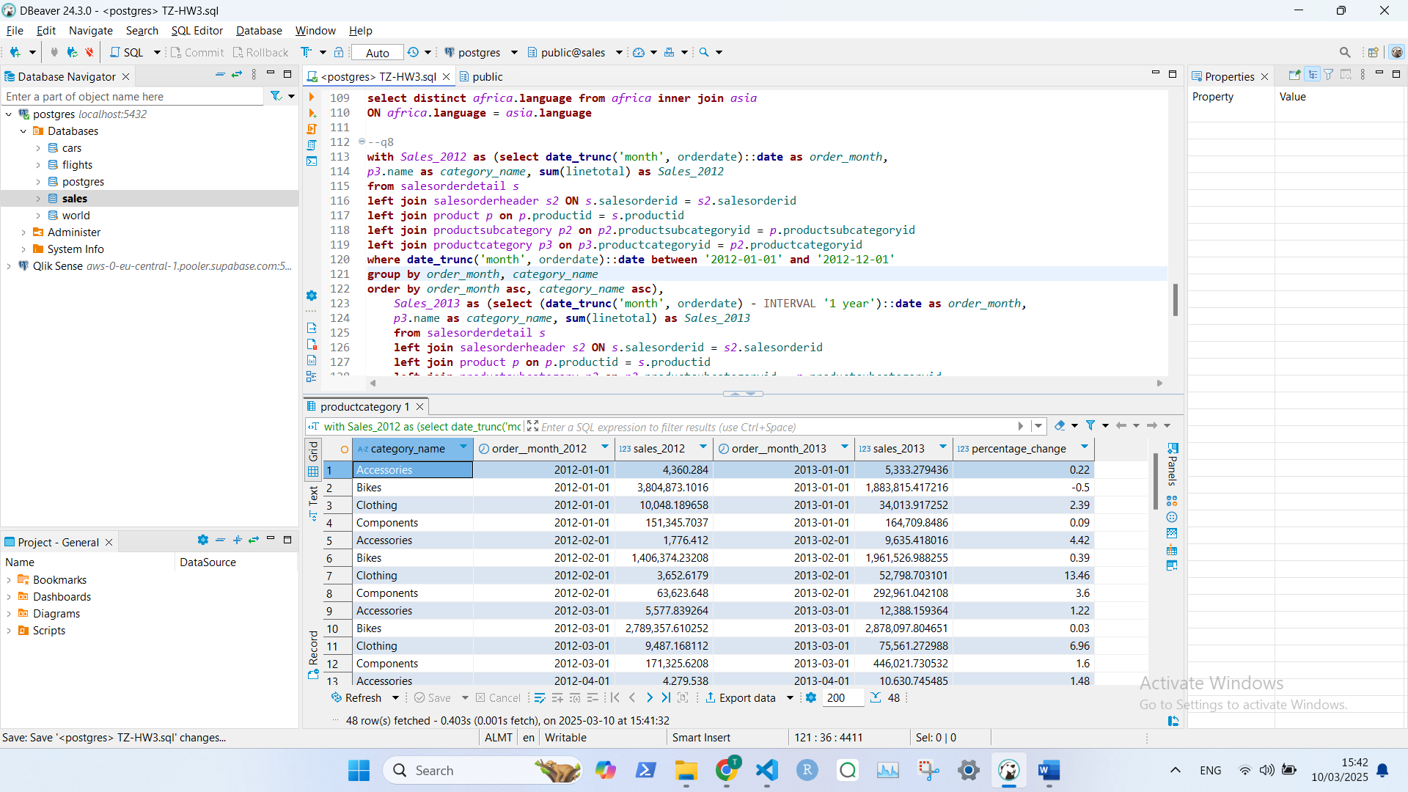

**Задача 9.**

**with** departure **as**

(**select**

departure_airport **as** airport,

**count**(**distinct** f.flight_id) **as** departure_flights,

**count**(**distinct** f.flight_id || '-' ||boarding_no) **as** departure_passengers

**from** flights f

**left** **join** boarding_passes bp

**on** f.flight_id = bp.flight_id

**where** actual_departure **is** **not** **null**

**and** **extract** (**year** **from** f.actual_departure **at** **time** **zone** 'Europe/Moscow') = 2017

**and** **extract** (**month** **from** f.actual_departure **at** **time** **zone** 'Europe/Moscow') = 3

**and** boarding_no **is** **not** **null**

**group** **by** departure_airport

**order** **by** departure_flights **desc**),

arrival **as**

(**select**

arrival_airport **as** airport,

**count**(**distinct** f.flight_id) **as** arrival_flights,

**count**(**distinct** f.flight_id || '-' ||boarding_no) **as** arrival_passengers

**from** flights f

**left** **join** boarding_passes bp

**on** f.flight_id = bp.flight_id

**where** actual_arrival **is** **not** **null**

**and** **extract** (**year** **from** f.actual_arrival **at** **time** **zone** 'Europe/Moscow') = 2017

**and** **extract** (**month** **from** f.actual_arrival **at** **time** **zone** 'Europe/Moscow') = 3

**and** boarding_no **is** **not** **null**

**group** **by** arrival_airport

**order** **by** arrival_flights **desc**),

names **as** (**select** departure_airport **as** airport **from** flights

**union**

**select** arrival_airport **as** airport **from** flights)

**select** names.airport,

departure_flights,

departure_passengers,

arrival_flights,

arrival_passengers,

departure_flights + arrival_flights **as** total_flights

**from**

names **left** **join** departure **on** names.airport = departure.airport

**left** **join** arrival **on** names.airport = arrival.airport

**where** departure_flights + arrival_flights > 0

**order** **by** total_flights **desc**

